

|  |  |  |  |  |  |  |  |  |
| --- | --- | --- | --- | --- | --- | --- | --- | --- |
|  | | | | | | | | |
|  | | Data Quality Report | | | | |  | |
|  |  | | | | | | |  |
|  | | | |  |  | | | |
|  | | | | Erifeoluwa Jamgbadi |  | | | |
|  | | | | 12/10/2021 – 31/10/2021—Machine Learning for Data Analytics—C18387973 |  | | | |
|  | | |  | | |  | | |

Table of Contents

Features (categorical vs. continuous) 3

Potential data quality issues with the data 4

• Missing values 4

• Outliers 4

• Feature cardinality issue 4

My opinion as to what should be done to address these quality issues 5

# Features (categorical vs. continuous)

I sorted out which one was categorical and which one was continuous on paper, this helped me to identify, which data belonged to either of the two.

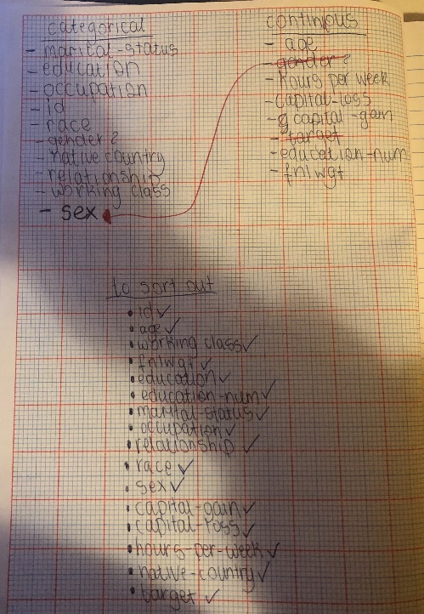

**Continuous Data from csv**

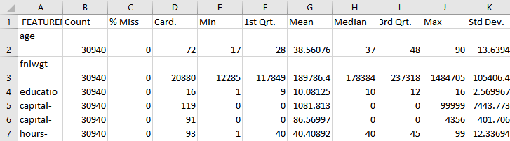

**Categorical Data from csv**

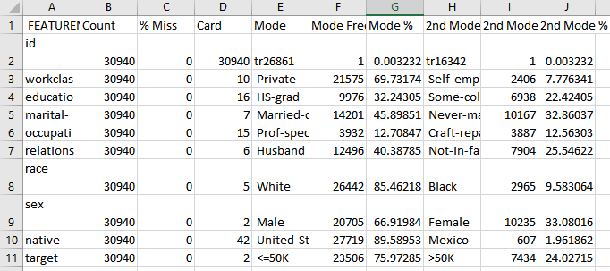

# Potential data quality issues with the data

## Missing values

To find the missing data, I filtered it out in excel:

Id – no missing values

Age – no missing values

Workclass – has missing values

Fnlwgt – no missing values

Education – no missing values

education-num – no missing number

marital-status – no missing values

occupation – has missing values

relationship – no missing values

race – no missing value

sex – no missing value

capital-gain – no missing value

capital-loss – no missing value

hours-per-week – no missing value

native-country – has missing value

target – no missing value

**Analysis:**

* There is a correlation between working class and occupation. People who have both the data from working class and occupation missing could mean has never worked because from the data, there are some who have occupation missing, but have working class and its says never worked. I noticed that these people were in some sort or school or still 18 years old. It also depends on age and education because it shows where both these are blank, the people are just 18, still in some form of school e.g. high school or have probably retired and/or couldn’t find a job/never worked, so I would either remove them or better yet, just put them as never worked. I would more likely put their working class as never worked, if they were 18 or in some sort of education e.g college. If they were of retiring age, I would fill those missing data of working class with retired.
* Those that have a missing value of native-country has a more chance of having a target of less/equal to 50000k, than with more than 50000k. There could be a number of reasons for this, which the data would not allow me to know, but I would be able to make different guesses.

## Outliers

To find the missing data for the continuous data, I worked it out in excel. For each feature heading of the continuous data e.g education num, capital-gain etc, I found the outliers with this method:

* Got the 1st quartile
* Got the 3rd quartile
* Got the interquartile range
* Used those values to get the upper bound
* Used those values to get the lower bound
* Then the values of those features were compared

**Analysis:**

* Capital-gain and capital-loss a high maximum value compared, especially compared to the median and 3rd quartile.
* For my analysis, I found out, a person would be more likely to get a capital gain, if they were a male, lived in the United States and their person target is more than 50000, then they would be more likely to get a capital-gain that is higher.
* For others, their capital-gain would be smaller if their target is less or equal to 50000.
* This analysis makes sense. I believe from analyzing the data, that capital-gain is dependent on target.

## Feature cardinality issue

**Analysis:**

* For the education-num, there is nothing wrong with this data, but I don’t think its very useful for predictions, especially since the education is there.

# My opinion as to what should be done to address these quality issues

*I also put some of my opinion on what should be done to address some of the data quality issues in my analysis in the potential data quality section.*

# I believe imputation should be used to replace the missing value feature with a plausible estimated value based on the feature values that are present. For the continuous features, I would replace the missing values with either the mean or median and for the categorical features, I would replace it with the mode. The median, mean or mode are good options to use because they represent the data and what the missing value could be or how they might be within that range, so that’s the main reason I would use them to replace missing values. I would only use imputation, if the missing values are less than 30% because then the data wouldn’t be as accurate or won’t be good quality especially, if the missing data replaced is definitely over 50%.

I would use clamp transformation for the outliers. This will help to make the data quality better because I would be removing the offending outliers. The outliers that have the maximum value 99999(capital-gain) are too high, especially against the min 0 (capital-gain), so I believe it would be better to remove them. Therefore, for capital-gain, lower limit of 0 and upper limit of 99999.

For the cardinality issue, I would remove the education-num column/feature because I don’t think it’s very useful especially since we have the name of the education in the data.